I am the LORD your God.
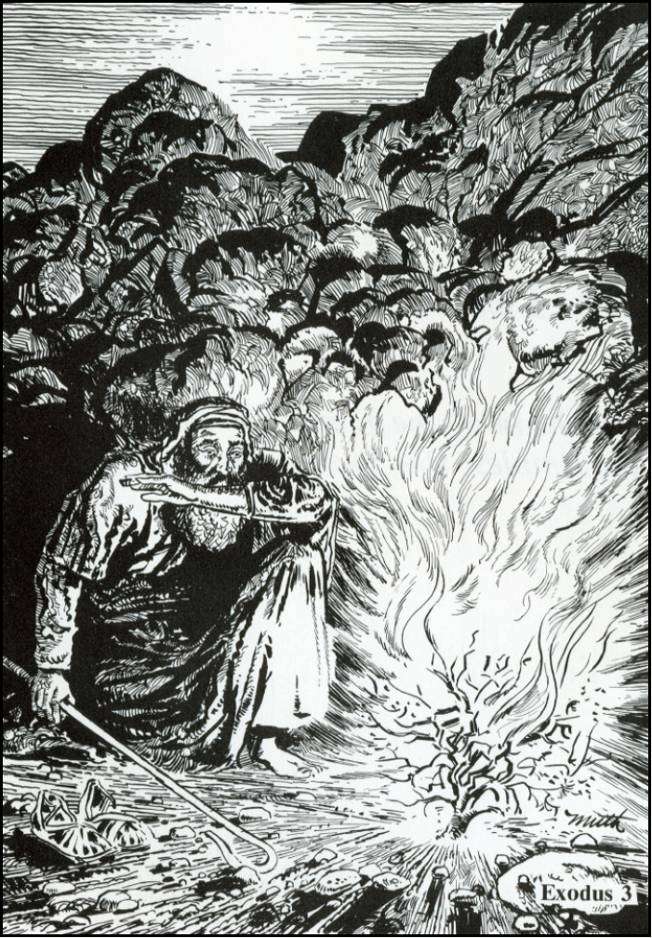
The 3 Purposes of the Law
1 Timothy 1:9-10 – Curb (to keep in check the wickedness of ALL People)

Romans 3:19-20 - Mirror (Chief Purpose – To show ALL people their sin and need for a Savior)

Psalm 119:1-5 - Guide (Shows CHRISTIANS how to live in thanks and praise to God)

Read Exodus 3
1. What is another name for Horeb?
--Mt. Sinai

2. What strange sight did Moses see?
--Bush that was on fire but didn’t burn up

3. Why didn't the bush burn up?
--the LORD was appearing to Moses in the bush

4. What did God tell Moses to do? Why?
--Take off his sandals
--He was standing on holy ground (in the presence of the HOLY one!)

5. Describe Moses' reaction as you look at the picture. Why do you think he feels that way? – He is afraid
-- He is looking at the appearance of the LORD himself (he is a sinner in the physical presence of the Holy God)

6. In verse 14, God tells Moses his name. What is it? The LORD – YaHWeh – “I AM”
יהוה
7. What do we learn about God from his name?
--doesn’t change -- faithful -- always keeps his promises -- Savior God (Ex. 34:6-7)
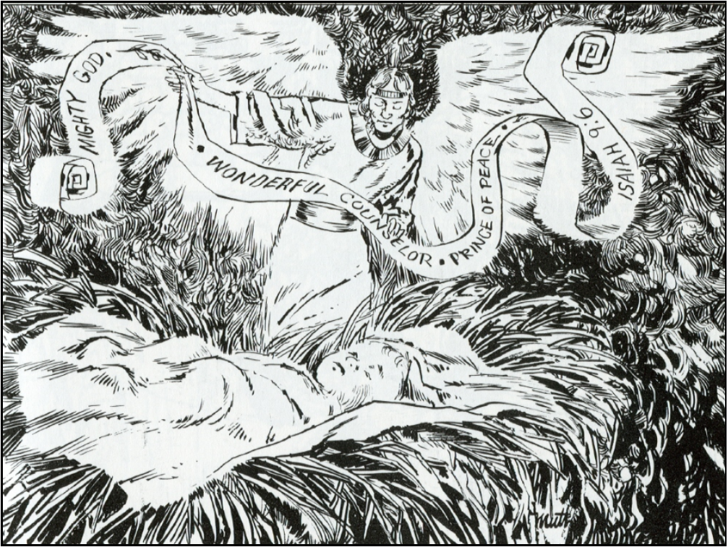
Read Isaiah 9:6
7. Who is the child in the picture?
--baby Jesus

8. Who is the other character?
--One of the LORD’s angels

9. What is he doing?
--carrying a banner covered with names

10. What is the child's name?
--Wonderful Counselor, Mighty God,
Everlasting Father, Prince of Peace

11. What did he come to do?
--save us from our sins

12. Why start our study of the 10 Commandments focusing on the LORD our God and his special names? -- we need to remember who he is and what he has done for us
--10 Commandments point out our sin and inability to save ourselves (Law)
--But when we hear who God is and what he has done (the LORD our Savior God) we hear the Good News of forgiveness and salvation in Jesus (Gospel)
--It’s this Good News that moves us to want to live as God wants (Law as Guide)

